Ribbon Writers
Description:
The Ribbon writers sit at the ribbon writer table which is adjacent to the Scorer table. There is a ribbon writer from each team. They receive the event sheets from the scorer and read them to determine which swimmers get which place ribbons. Then they write in the swimmer’s name on the appropriate place ribbon and if necessary highlight the event the swimmer won.
The ribbons that are won by our team are organized in a binder by event and given to the Coaches to distribute the day after the meet. The ribbons for the opposing team are organized by their ribbon writer.
Example:

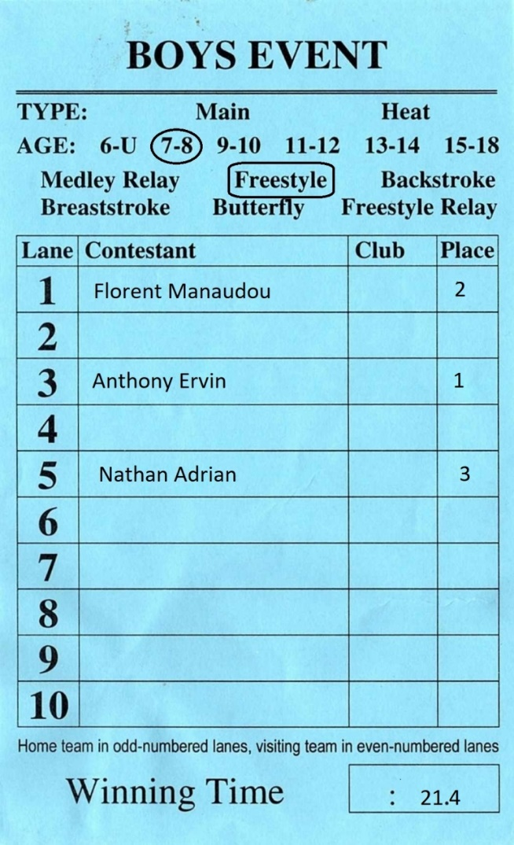
In this event we won the top three places. The home team Ribbon writer looks at the event sheet and writes in the names for the first, second and third place finishers on the appropriate ribbons.

Tips:
Ribbons are provided by the home team. If you're writing for an away meet, you need to go with the flow. Other teams may or may not fill out and apply the stickers before the meet (most do, but not always).

The scorers fill out the places on the blue/pink sheets. If there's a question about a tie or a DQ, defer to the scorer to make the correction on the blue/pink sheet before you write the ribbons. There are always lots of DQs in 6&u and 7&8 breaststroke, so wait till all the DQ sheets come in before writing those ribbons.

Length of time commitment at the meet:
Ribbon writers have to stay till the very end and the relays at the end of the meet keep you busy. If you sign up for this position make sure you're available till 9:30/10pm-ish.

